User’s Manual

JOBMOD
Employment Estimation Model

March 28, 2002

Presented to

U.S. Department of Transportation
Federal Highway Administration

Office of Transportation Policy Studies (HPTS)

Introduction
JOBMOD is an income and employment estimation model. It provides transportation policy makers with empirical estimates of the effects of federal-aid construction spending on jobs and employment income in the highway construction industry, industries that supply construction materials and equipment, industries that provide inputs to the production of construction materials and equipment, and the economy in general.

The Input-Output model provides an appropriate analytical framework for evaluating the effects of highway construction spending on income and employment in the U.S. economy. One readily available model is the 1992 Benchmark Input-Output Accounts of the United States, which can be obtained from the U.S. Department of Commerce. However, this model does not contain sufficient industrial detail to consider the effect of changes in spending on different types of highway improvements. Because of systematic differences in labor and materials requirements for different types of highway construction projects, changes in the composition of federal-aid program spending can affect the overall level of income and employment generated, and the incidental benefits to material-supplying industries and other sectors of the economy.

To incorporate the economic impacts of changes in program composition on income and employment, JOBMOD expands the highway construction and maintenance categories in the 1992 Benchmark Input-Output Accounts of the United States by creating 14 pseudo-industries, one for each of the federal-aid highway improvement types. (See Appendix A for descriptions of the improvement types.) Labor and material requirements for the different types of highway projects are obtained from a statistical analysis of completed federal-aid highway projects in the Statement of Materials and Labor Used by Contractors on Highway Construction Involving Federal Funds (Form-47) database. The FHWA Fiscal Management Information System (FMIS) database is also used to provide financial and improvement type details for completed projects. Unlike generally available input-output models, JOBMOD income and employment estimates are sensitive to both the level and composition of federal-aid program expenditures.

A further difference between JOBMOD and other input-output models is the way income and employment estimates are reported. JOBMOD presents results for three rounds of spending. This approach differs slightly from the standard input-output convention of reporting results in terms of direct, indirect, and induced impacts. Most input-output models limit “direct” effects to the industry or economic sector in which the initial spending occurs and classify all other impacts on the production sector due to the initial spending as “indirect” effects.

Since a large portion of highway project cost is for materials and equipment, presenting JOBMOD results in terms of three rounds, with the first round including the effects of construction spending on materials supplying industries, better conveys the immediate connection between highway construction activity and economy. The three rounds of employment effects reported by JOBMOD are defined as follows:

- First-round employment includes all those jobs that are created either by the construction firms that execute the project or by the firms who provide direct inputs (paving material, structural steel, guardrail, concrete, earth-moving equipment, lighting, etc.) to the construction project. This definition is somewhat broader than the conventional definition of “direct” employment because it includes jobs in sectors other than the sector in which spending initially occurs. However, since the model reports employment impacts by economic sector, direct employment benefits to the highway construction industry can be obtained by referring to results for the “construction” sector in the detailed first-round output reports.

- Second-round employment impacts include jobs in firms that provide inputs to the industries that directly provide materials and equipment used in highway construction. For example, while a job in a firm that produces guardrail is counted as a first-round employment effect, a job in a firm that provides the sheet steel to make the guardrail is considered part of second-round employment. Our definition of second-round effects is therefore somewhat narrower than the standard definition of “indirect” employment.

- Third-round employment includes all the jobs generated by the consumer expenditures that result from the wages paid for first and second round employment. It is equivalent to the standard input-output definition of “induced” employment.

For a more detailed explanation of the employment generation methodology, criteria for software design, and an illustrative example of the use of JOBMOD, please refer to “Final Report D: JOBMOD Software Package for Estimating Employment Impacts of Highway Projects,” written by the Boston University Center for Transportation Studies, May 2001.

Overview and Procedure

for Using JOBMOD
JOBMOD is an open-ended or unconstrained input-output model. No restrictions are imposed on the availability of labor, construction materials, or other inputs to production. In effect, the model assumes that adequate quantities of all inputs are available to meet production needs regardless of the level of total spending. This is not the case with more comprehensive models that often contain feedback mechanisms (such as general price increases) to assure market clearing. Consequently, JOBMOD may tend to overestimate income and employment benefits of construction spending in a full-employment economy operating at high levels of capacity utilization or when critical raw materials shortages limit producer ability to expand output and production. The user is therefore urged to consider the magnitude of construction program spending and prevailing general economic conditions when interpreting JOBMOD results.

The Visual Basic software environment of JOBMOD encourages the organization of model inputs and analytical results into a series of forms. Each form is a template into which input data may be entered or output data may be displayed. The program has been organized into a series of thirteen forms depicted below in Figure 1.
Figure 1. Basic JOBMOD Program Structure

Procedures for running JOBMOD, as well as the various forms employed in JOBMOD, are described in detail below:

The JOBMOD program can be run directly from the CD (or downloaded onto a hard drive). The JOBMOD file folder will include five data files (AMatrix, EmpCoeffs, Li1, Li2, and PYCoeffs40wks) and one executable JOBMOD program file (JOBMOD.exe).

- Insert the JOBMOD CD into the computer’s CD drive. Using “My Computer” or Windows Explorer, select the JOBMOD drive (note the letter of the CD drive). Double-click on the JOBMOD file folder. This folder should contain the 6 files mentioned earlier.

- Open the program by double-clicking on the JOBMOD.exe application file. This will start JOBMOD and display Form 1, Welcome to JOBMOD 1.1. Click on the “Begin” button to enter the program.

- The next screen will ask for the CD drive from which the software is running. Choose the appropriate drive (on most computers this is drive D, E, or F). Click on “Continue”. This will cause all required data files to be loaded into the computer memory. This will take a few moments.

- On any given form, the user has the option to print the screen or exit the program. In addition, some forms have the option to return to a prior screen by using the “Previous” button or saving results to an Excel spreadsheet file.
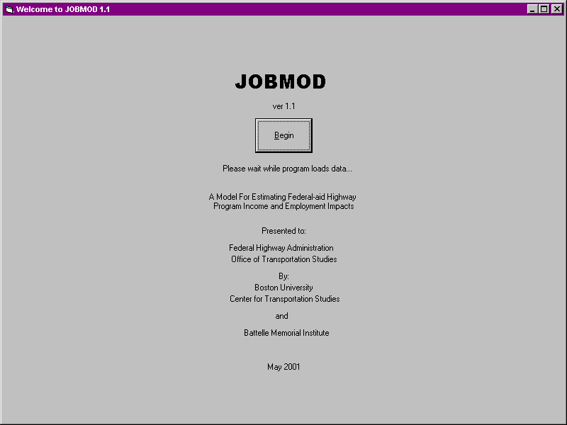
Form 1. Welcome to JOBMOD 1.1

- Form 2, Expenditures, asks the user to specify the value of federal-aid expenditures for which income and employment impacts will be calculated. Enter this amount.

- The form asks whether the amount includes “state matching funds”. It also asks the user to enter a state “matching share” contribution. Input this percentage in the appropriate box. If there is no state matching funds, zero MUST be entered into the state matching fund percentage box, otherwise an error will occur. At any point, the “Clear Form and Start Again” button can be clicked to clear the values in the boxes.

- Once these values are input, click on the “Calculate” button to calculate federal and state contributions. The program will automatically calculate the federal contribution, state matching contribution, and combined federal and state expenditures. Click on the “Next” button to continue.
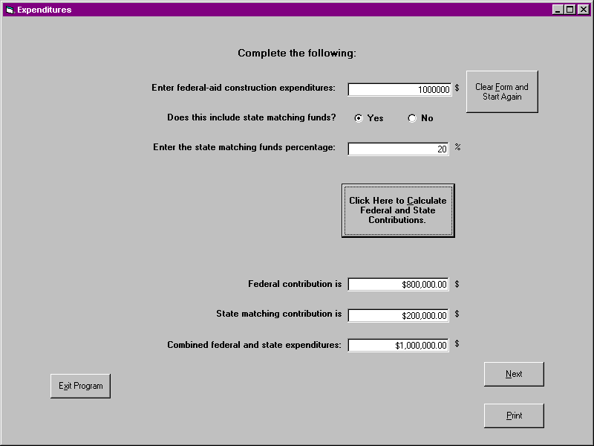
NOTE: The user is required to specify an amount of construction spending. However, in JOBMOD ver. 1.1, the scope of included expenditures is somewhat ambiguous. This is because the underlying project data for first-round employment estimates excludes preliminary engineering (PE) and right of way acquisition (ROW) costs, but the inter-industry coefficients used to estimate second- and third-round impacts obtained from the 1992 Benchmark Input-Output Accounts for the United States undoubtedly reflect transactions that can be traced to these two types of expenditures. A conservative approach to using JOBMOD for income and employment estimation is to exclude PE and ROW costs from total spending.
Form 2. Expenditures

Some users may attempt to use JOBMOD to evaluate state-only or local highway spending programs. The user is cautioned that JOBMOD first-round estimates are based on an analysis of completed federal-aid highway construction projects with a total cost in excess of $1 million. Similarities (or differences) in labor and materials usage between federal-aid construction projects and state-only or local highway projects have not been rigorously investigated.

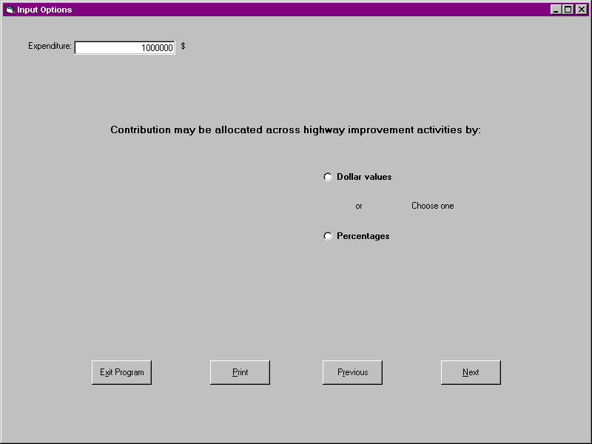
- On Form 3, Input Options, the total expenditure, as provided in the previous form, is displayed in the upper left corner. The user is given the option to allocate program expenditures across the fourteen improvement types either as dollar values or percentages. Choose “Dollar Values” or “Percentages.” If you fail to make a choice, an error message will appear. Click on the “Next” button to continue or the “Previous” button to go back.
Form 3. Input Options
NOTE: On Forms 4 and 5, the user is required to specify the improvement type composition of program spending. It is possible to restrict a given level of spending to one or a few improvement types. Some users may be inclined to use this facility as a way to evaluate the economic effects of a single project. However, the user is warned against doing this because employment and material intensity coefficients for highway improvement types are average values for a relatively large number of federal-aid projects and should not be considered indicative of any single project.

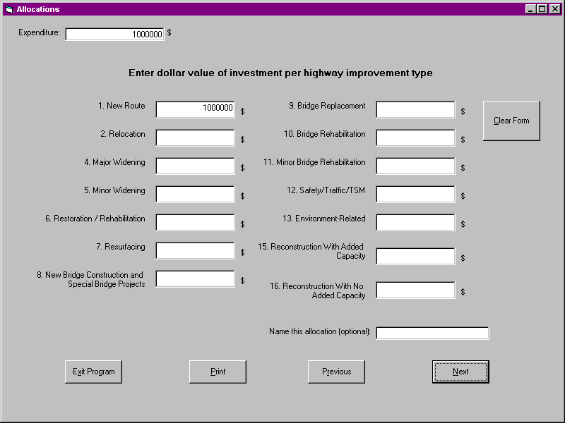
- If the option to enter “Dollar Values” is chosen, Form 4, Allocations, will appear with the fourteen highway improvement types. For more detailed information on the highway improvement types, refer to Appendix A. Once again, the total expenditure value is displayed in the upper left corner of the screen. Enter the dollar amounts of expenditures for each highway improvement type into the appropriate boxes making sure the total values entered sum to the total expenditure value. If not, an error message will appear. The “Clear Form” button can be used to clear all values from the boxes on this form. The user is also given the option to name the allocation in the lower right portion of the screen. This option will prove useful if multiple runs based on different distribution scenarios are being analyzed. Click on the “Next” button to continue.
Form 4. Allocations (Dollar Values)
- If the option to enter “Percentages” is chosen, Form 5, Allocations, will appear with the fourteen improvement types listed. The initial screen will display default percent values and the allocation name “Default.” To clear the default values, click on the “Clear Form” button. Enter appropriate percent values in the boxes to be sure the total adds to 100%. If the total does not add to 100%, an error message will appear. Click on the “Reset Form to Default Values” at any time to return to the default values. The user may name the allocation. This name will appear on subsequent output forms. Click on the “Next” button to continue. At this point the user input is complete and all data have been assigned to variables in memory so that calculations can be implemented.

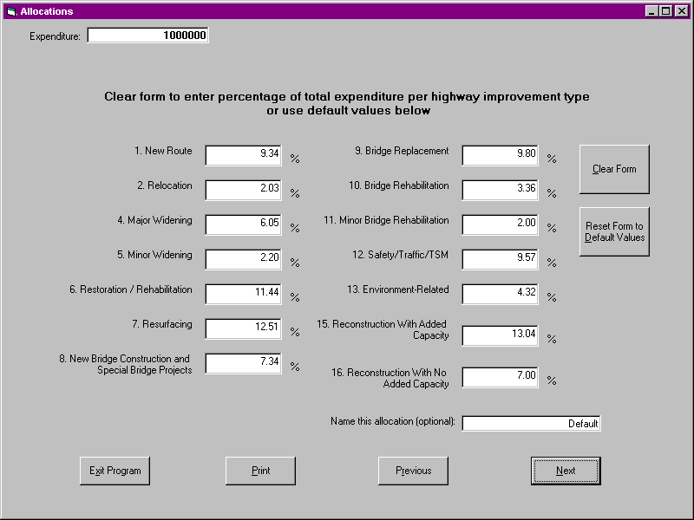
Form 5. Allocations (Percentage Values)

- The next screen, Form 6, allows the user to choose an output option. The user may choose one of the following:

- Dollar values of commodities and services produced and employment generated across all industry sectors. This option provides a summary of first-round, second-round, and third-round inter-industry effects aggregated over all industry sectors.
- Person-years of employment generated across twelve industry sectors. Note that first-round, second-round, third-round, and total effects are detailed in this option.

- Person-years of employment generated across forty-eight industry sectors. Note that this option requires further selections to view first-round, second-round, third-round, and total effects for all forty-eight industry sectors due to the large amount of data outputs.

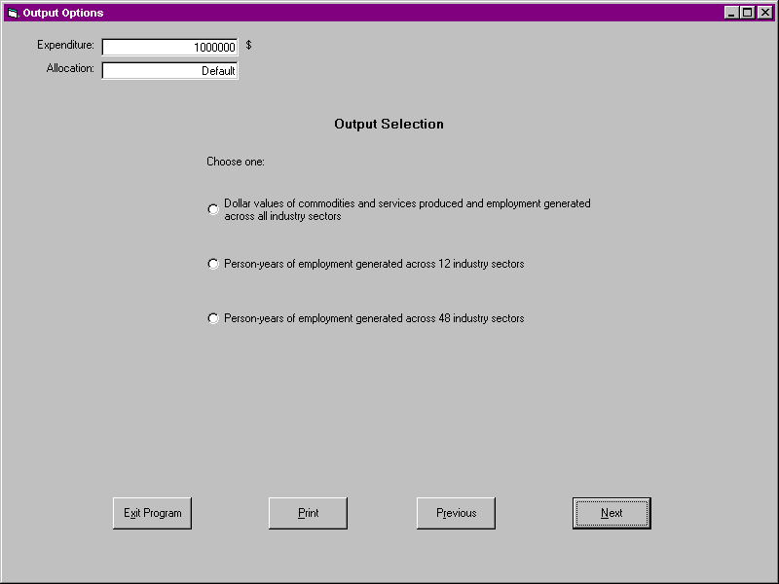
Choose an option and click on “Next” to continue
Form 6. Output Options

NOTE: The timing (as well as the magnitude and incidence of economic benefits) is important to transportation policy makers. However, JOBMOD reports employment impacts only in terms of “person-years.” The temporal distribution of income and employment benefits is not specifically considered in the current model.

- If “All Industry Sectors” is selected, Form 7, Aggregate Economic Effects of Highway Investment, appears. Calculations can then be performed to determine first-round, second-round, third-round, and total employment income and person-years for that allocation. Also included are the dollar values of the first and second round and all three rounds of goods and services generated. Click on the “Perform Calculations” button to view calculated values. The software will automatically calculate the values and display them. Any of the output screens from this point may be saved into a spreadsheet form by clicking on the “Save to Spreadsheet” button.
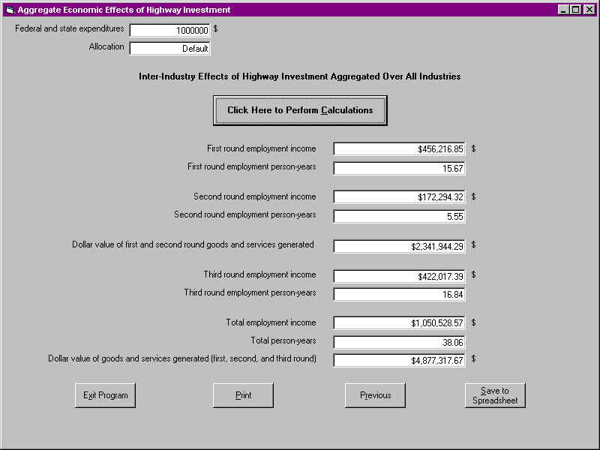
Form 7. Aggregate Economic Effects of Highway Investment
(All Industry Sectors)
- If “12 Industry Sectors” is chosen as an output option, Form 8, Sectoral Effects of Highway Investment, will appear in which twelve of the more detailed sectors such as mining, textiles, chemicals, etc. will be listed. Click on the “Calculations” button and the program will calculate the first-round, second-round, third-round, and total person-years of employment generated for these sectors. Once again, the values may be saved to a spreadsheet.

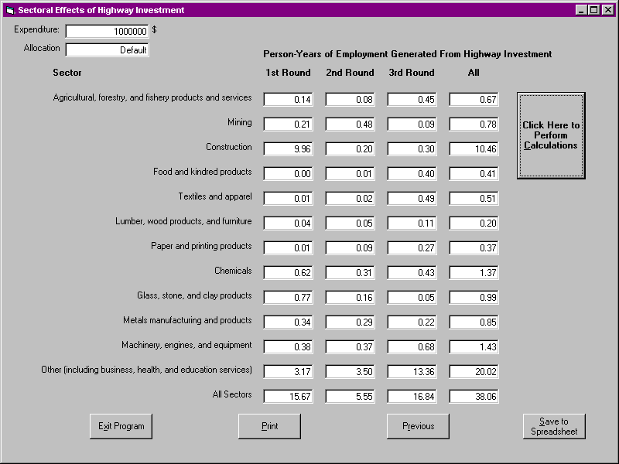
Form 8. Sectoral Effects of Highway Investment (12 Industry Sectors)

- If “48 Industry Sectors” is chosen as an output option, Form 9 appears which gives the user additional options and detail for forty-eight sectors. The user can then choose among four additional output options:

- First-round employment generated by highway investment (Form 10)
- Second-round employment generated by highway investment (Form 11)
- Third-round employment generated by highway investment (Form 12)
- Total employment generated highway investment (Form 13)

Choose an option and click “Next” to continue.

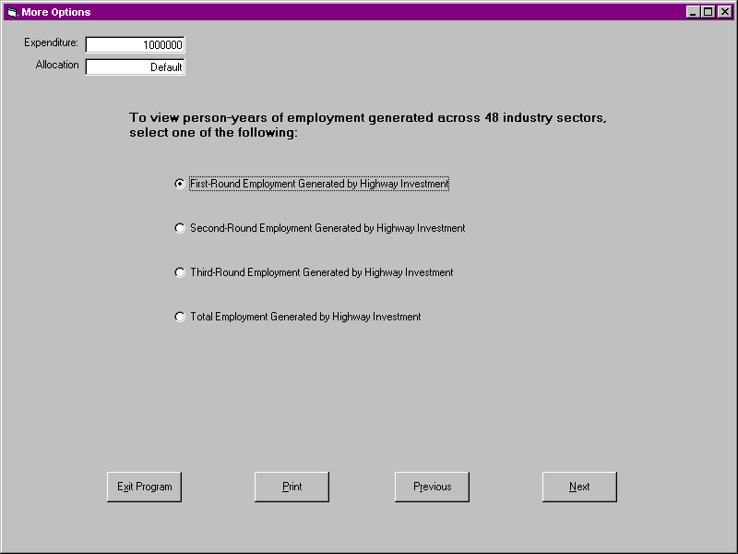
Form 9. More Options (48 Industry Sectors)

- If first-round employment is chosen, Form 10, Sectoral Effects of Highway Investment, is displayed with forty-eight detailed industry sectors listed. Click on the “Calculations” button and the software will automatically calculate all first-round person-years employment for each individual sector and the total values for all sectors. Again, these values can be saved into a spreadsheet format.

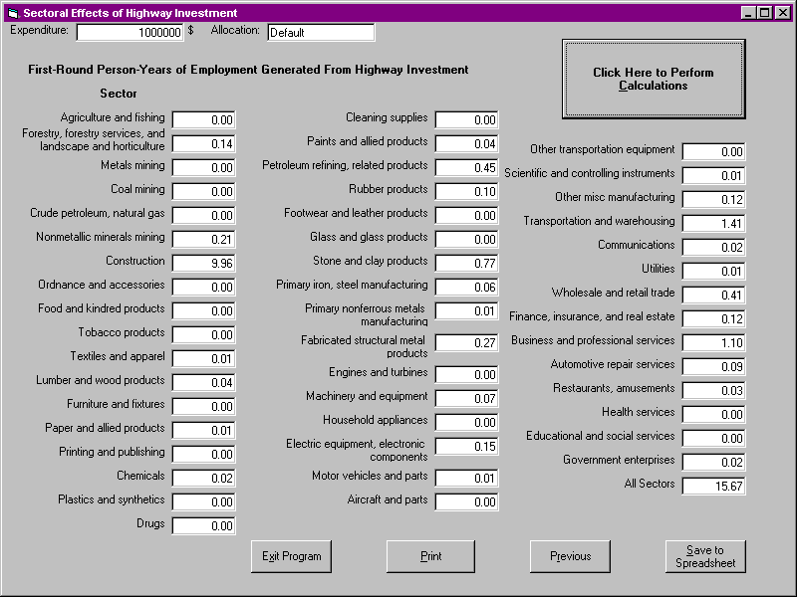
Form 10. Sectoral Effects of Highway Investment
(First-Round Employment Values for 48 Industry Sectors)

- If second-round, third-round, or total employment is chosen, Forms 11, 12, or 13, Sectoral Effects of Highway Investment, will be displayed respectively. As in step 13, click on the “Calculations” button to view employment values for those rounds for all forty-eight sectors. Save values to spreadsheet if desired.

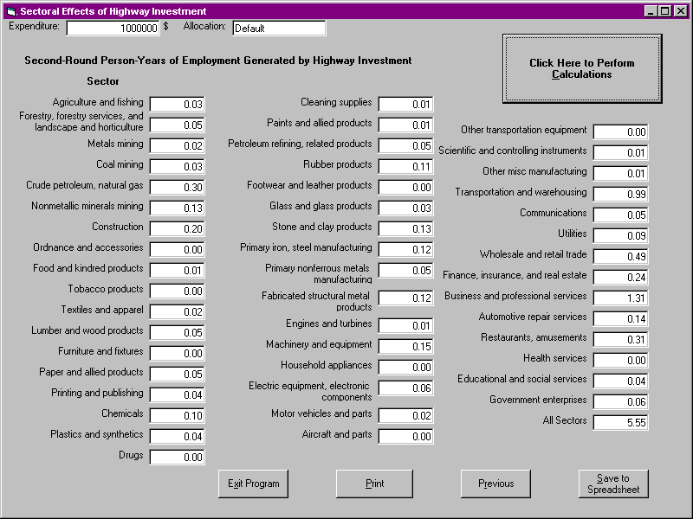
Form 11. Sectoral Effects of Highway Investment
(Second-Round Employment Values for 48 Industry Sectors)
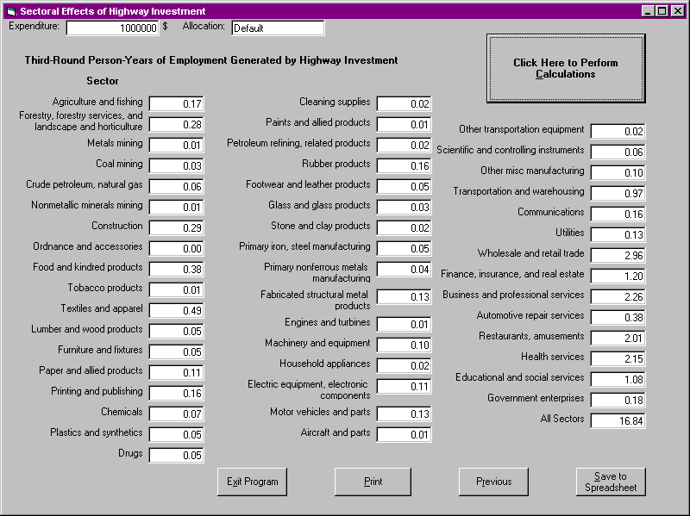
Form 12. Sectoral Effects of Highway Investment
(Third-Round Employment Values for 48 Industry Sectors)
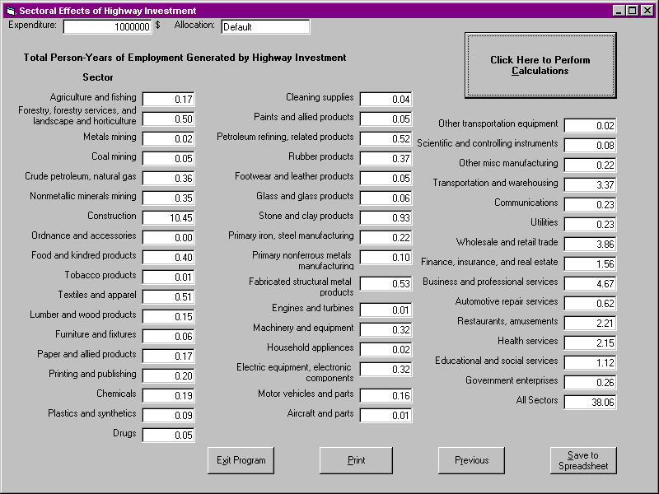
Form 13. Sectoral Effects of Highway Investment
(Total Employment Values for 48 Industry Sectors)

Appendix A

Improvement Type Descriptions

Code 01: New Route: construction of a new facility that will not replace or relocate an existing facility

A new facility will provide (1) a facility where none existed previously or (2) an additional and alternate facility to an existing facility that will remain open and continue to serve through-traffic.

Code 02: Relocation: construction of a facility on a new location that replaces an existing route

The new facility carries all the through-traffic with the previous facility closed or retained as a land-service road only.

Code 04: Major Widening: the addition of lanes or dualization of an existing facility where the existing pavement is salvaged

Also included, where necessary, is the resurfacing of existing pavement and other incidental improvements such as drainage and shoulder improvements.

Code 05: Minor Widening: widening the lanes and or shoulders of an existing facility without adding through-lanes

In many cases, the improvement will include resurfacing the existing pavement and other incidental improvements such as drainage and shoulder improvements.

Code 06: Restoration/Rehabilitation: work required to return an existing pavement (including shoulders) to a condition of adequate structural support or to a condition adequate for placement of an additional stage of construction

There may be some upgrading of unsafe features or other incidental work in conjunction with restoration and rehabilitation. Typical improvements would include replacing spalled of malfunctioning joints; substantial pavement stabilization prior to resurfacing; grinding/grooving of rigid pavements; replacing deteriorated materials; reworking or strengthening bases or sub bases; and adding underdrains.

Code 07: Resurfacing: placement of additional surface material over the existing roadway to improve serviceability or to provide additional strength

There may be some upgrading of unsafe features and other incidental work in conjunction with resurfacing. Where surfacing is constructed by separate project as a final stage of construction, the type of improvement should be the same as that of the preceding stage -- new route, relocation, reconstruction, minor widening, etc.

Code 08: New Bridge Construction and Special Bridge Projects: construction of a new bridge which does not replace or relocate an existing bridge

Code 09: Bridge Replacement: the total replacement of a structurally inadequate or functionally obsolete bridge with a new structure constructed in the same general traffic corridor to current geometric construction standards

A bridge removed and not replaced or replaced with a lesser facility is considered a bridge replacement. Incidental roadway approach work is included. The use of this code requires the reporting of the National Bridge Inventory (NBI) structure number in the data field identified as Bridge Numbers.

Code 10: Bridge Rehabilitation: major work required to restore the structural integrity of a bridge as well as work necessary to correct major safety defects

Bridge deck replacement (both partial and complete) and the widening of bridges to specified standards are included. Construction of a dual structure to alleviate a capacity deficiency is also included. The use of this code requires the reporting of the NBI structure number in the data field identified as Bridge Numbers.

Code 11: Minor Bridge Rehabilitation: work required to correct minor structure and safety defects or deficiencies such as deck patching, deck resurfacing, deck protective systems, upgrading railings, curbs and gutters, and other minor bridge work

Code 12: Safety / Traffic / TSM: a project or a significant portion of a project which provides:

(1) features or devices to enhance safety
(2) a traffic operation improvement, which is designed to reduce traffic congestion and to facilitate the flow of traffic (both people and vehicles) on existing systems
(3) conservation of motor fuels by reducing vehicle use or improving transit service

Code 13: Environment-Related: this category includes improvements that do not provide any increase in the level of service, in the condition of the facility, or in the safety features

Typical improvements, which would fall in this category, would include noise barriers; beautification and other environmentally related features not built as a part of the above identified improvement types.

Code 15: Reconstruction with Added Capacity: construction on approximate alignment of an existing route where the old pavement structure is substantially removed and replaced

Such reconstruction with added capacity may include increasing the number of lanes or widening to provide continuous additional through-lanes, or dualization, or revising interchanges, replacing other highway elements such as a grade separation to replace an existing grade intersection or otherwise improving the existing facility without changing the basic character of the facility.

Code 16: Reconstruction with No Added Capacity: essentially the same as the Code 15 reconstruction detail but with no added capacity (reconstruction that does not include the addition or widening of lanes)

